#### DEPARTMENT OF COMPUTER SCIENCE AND ENGINEERING

#### SUBJECT CODE:19CS2211

**SOFTWARE ENGINEERING TUTORIAL WORKBOOK**

**Name of the Tutorial #1,#2-- How to use Star UML and How to draw use case,Class,Sequence ,Activity and State chart diagram, Library Management System(LMS) by using star UML**

**Date of the Session: / / Time of the Session: to**

**Prerequisite:**

* + - **Software Engineering Methodologies..**
    - **Download the Star UML.**
    - **Basics of Software Engineering.**

## Pre-Lab Task:

1) UML Full form

**a) Uniform modeling Line**

**b) unified modeling language**

**c) Unilaterial modeling language**

**d) Unified Modeling Line**

2. Which of the following UML diagrams has a static view?  
a) Collaboration  
b) Use case  
c) State chart  
d) Activity

.3.What type of core-relationship is represented by the symbol in the figure below?  
[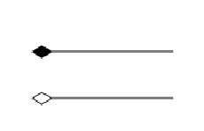](https://www.sanfoundry.com/wp-content/uploads/2013/07/software-engg-mcqs-diagrams-uml-1-q2.png)  
a) Aggregation  
b) Dependency  
c) Generalization  
d) Association

4. What type of relationship is represented by Shape class and Square ?  
[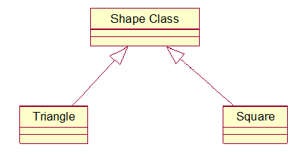](https://www.sanfoundry.com/wp-content/uploads/2013/07/software-engg-mcqs-diagrams-uml-1-q4.png)  
a) Realization  
b) Generalization  
c) Aggregation  
d) Dependency

.

**In Lab Task:**

Star UML Introduction

### [Download - StarUML](http://staruml.io/download)

staruml.io/download

Name of the software:Star UML

Version:-v2.8.0(http://staruml.io/download)

after downloading how to open the software

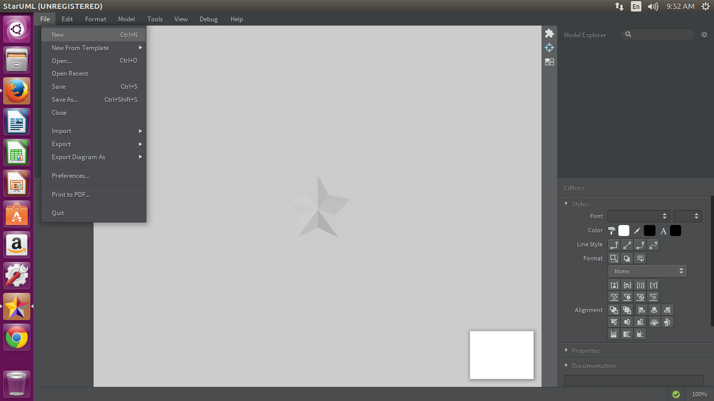

five windows in the interface of star uml

1) Working diagram Window- in this window the diagrams which we are able to draw

2) Tool box window- in this window the tools are displayed for the concerned diagrams

3) Main window- it is the location where we draw the diagrams

4) model explorer window- all the tools with their names are displayed

5) stlyes window- the apperance of each tool like color, font style etc are used from this window

To draw the use case diagram the procedure is

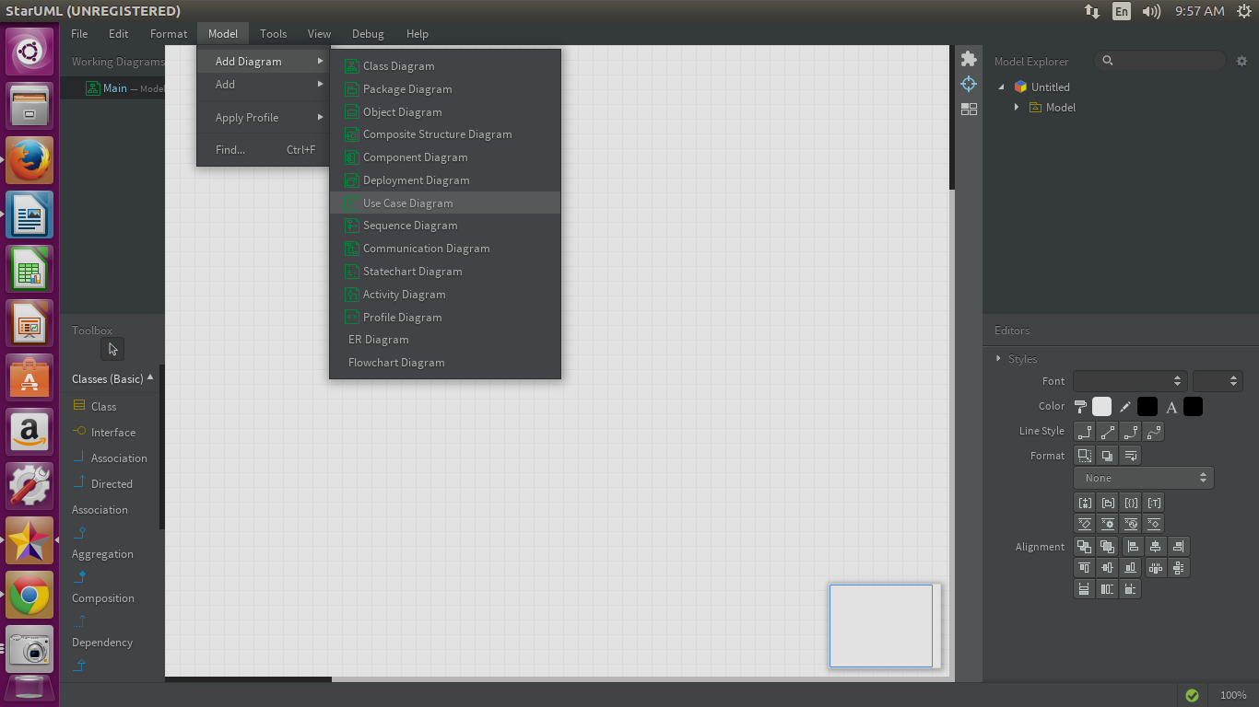

when we select the usecase diagram and placing the necessary tools that are required for drawing use case diagram

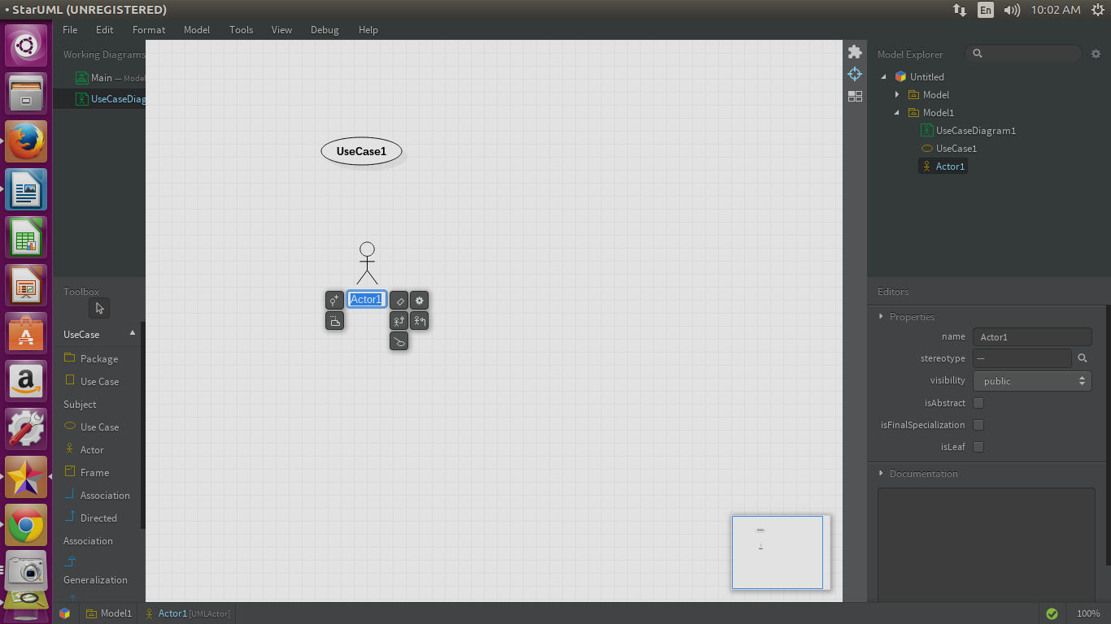

To draw activity diagram the procedure is

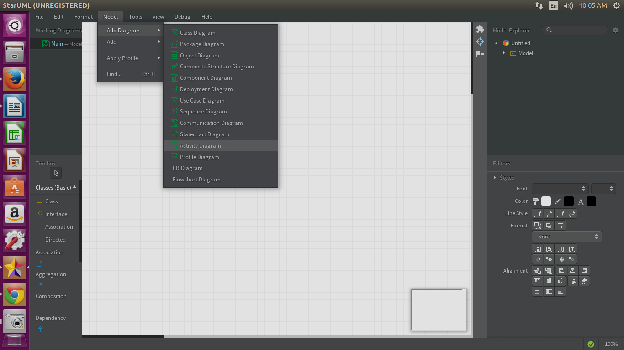

when we select the actvity diagram and placing the necessary tools that are required for drawing diagram

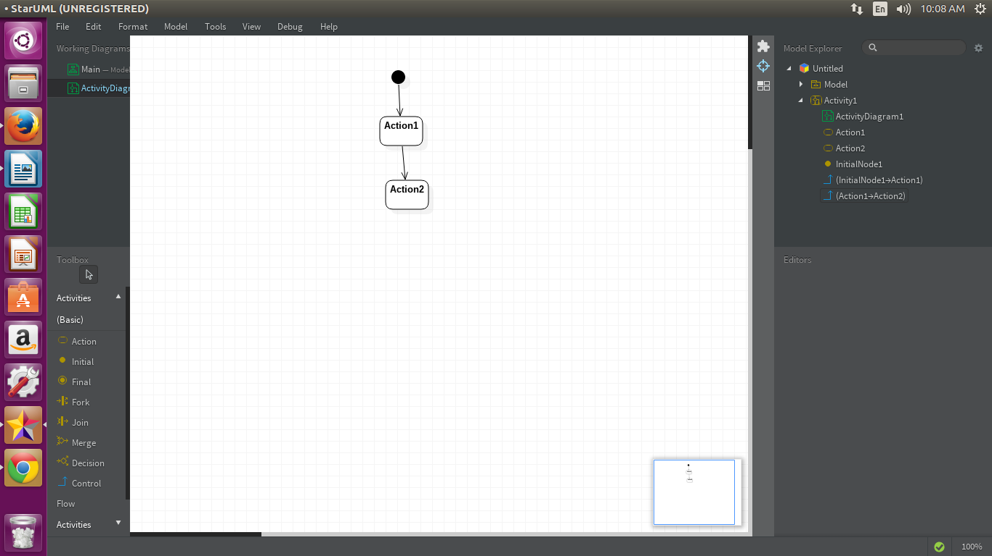

To draw class diagram the procedure is

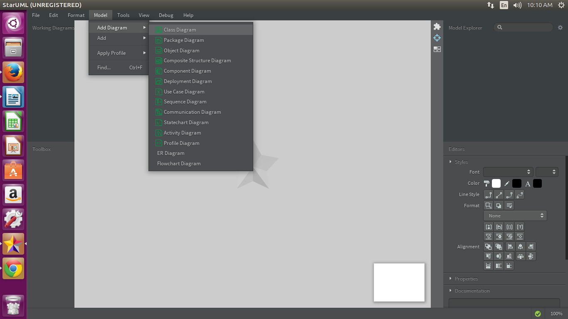when we select the class diagram and placing the necessary tools that are required for drawing diagram

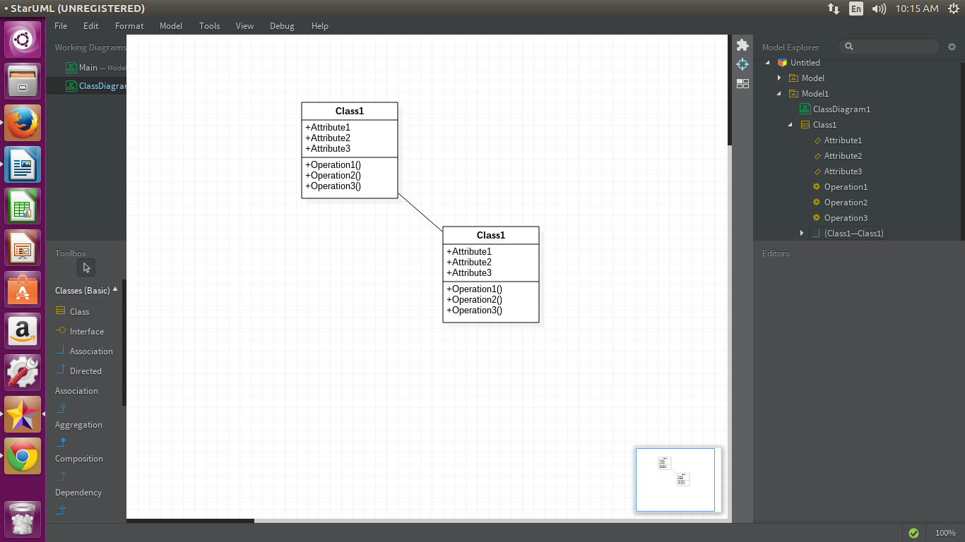

To draw sequence diagram the procedure is

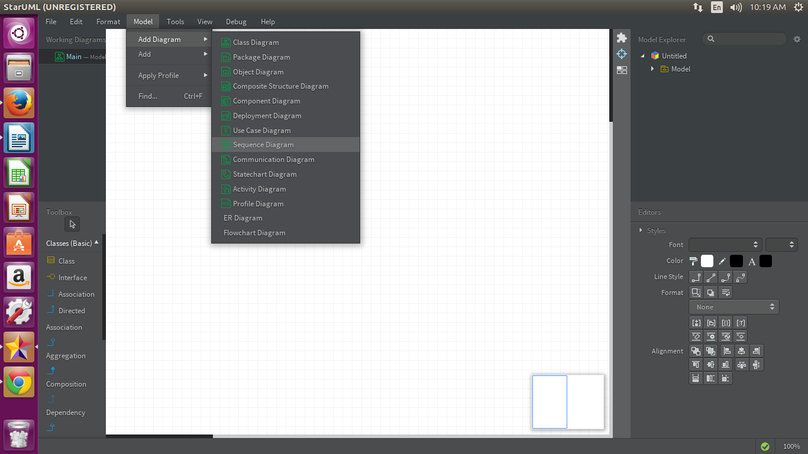

when we select the sequence diagram and placing the necessary tools that are required for drawing diagram

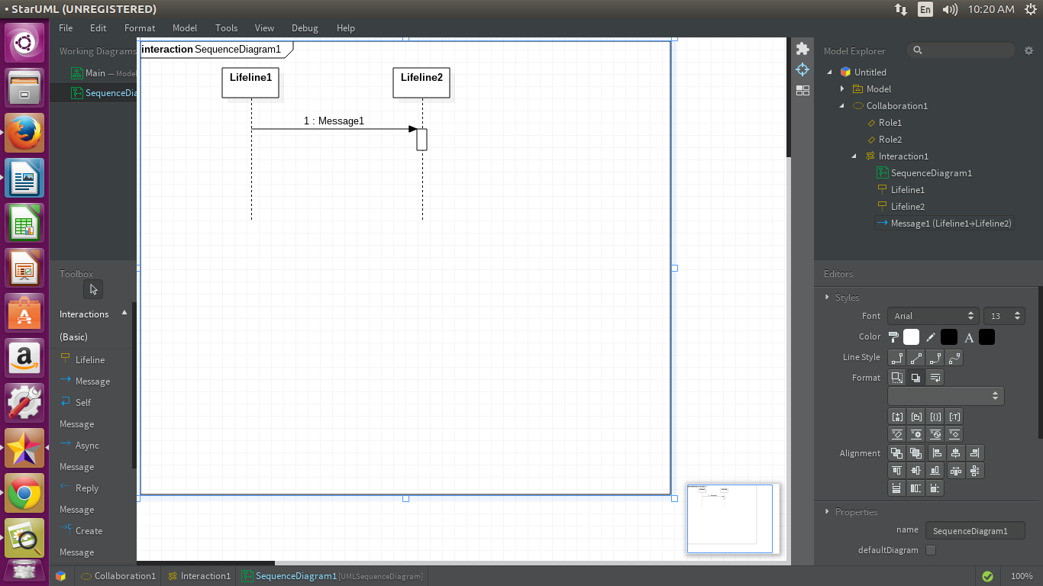

To draw state chart diagram the procedure is

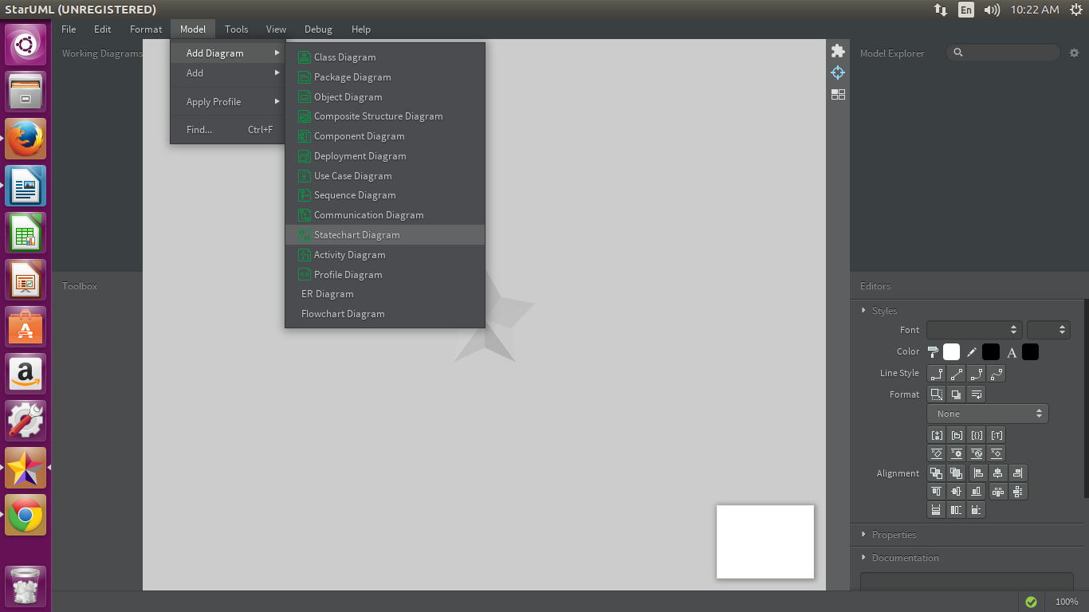

when we select the statechart diagram and placing the necessary tools that are required for drawing diagram

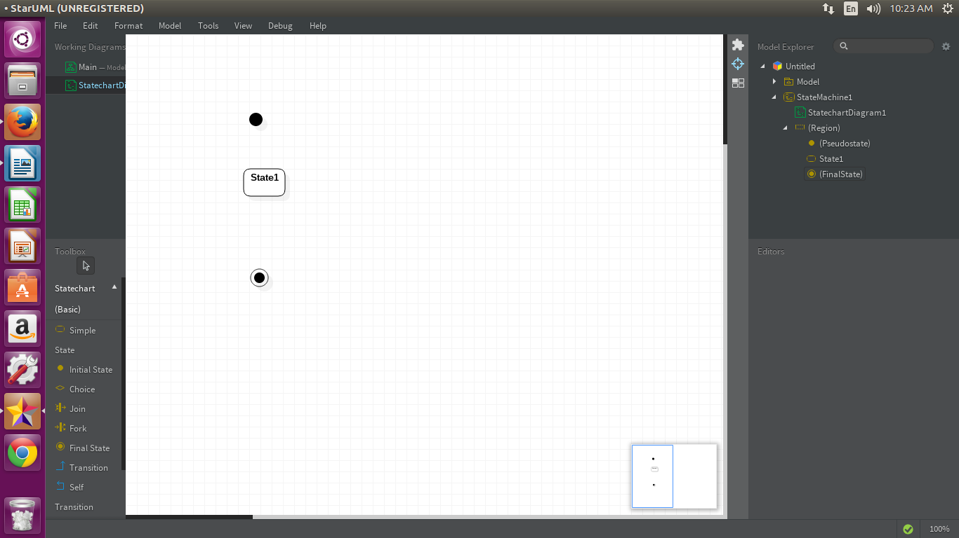

Library Management Case Study

The library management system project is related to the storage of information regarding the library. Library is the place with the huge collection of books. It is place from where the students and the faculties issue the books for their reference purposes. But the maintenance of keeping the records of issuing and borrowing is difficult if you use a normal book as a registry. To make this task easier, the library management system will be very useful. It helps in maintaining the information regarding the issuing and borrowing of books by the students and the faculties. The library management system case study gives the case study of the library management system

There will be many answers for these case studies, These are some possible answers

Use case diagram:

**Procedure**

* Click on tools and create an actor namely ‘student’, ‘librarian’, ‘supplier’ using createactor option.
* Click on toolsand create nine use cases namely ‘submit id card’, ’verify id card’, ‘grant permission’, ‘request to issue book’, ‘issue book’, ‘return book’, ‘search for database’ and ‘check the availability’, ‘issue the book if available’ using createuse case option.

**Procedure**

* Click on toolsand create eight classes namely ‘catalog’, ’librarian’, ’book’, ‘member’, ‘student’, ‘faculty’, ‘reference book’ and ‘issuable book’ using createclass option.
* Insert the attributes of catalog class i.e. name, created by and number of books as string type by opening the specifications window of catalog class
* Insert the operations to be performed in the Catalog class by clicking *operations* in its specification window. The operations are receiving add book with no return type, remove book having return type as double with no arguments.

**Class diagram for the LMS**

**ACTIVITY DIAGRAM FOR LMS**

STATE CHART DIAGRAM FOR LMS

**Post Lab Task:**

#### Writing space for the Problem:(For Student’s use only)

Draw all diagrams for the Word processor case study

Viva Questions

1. How many diagrams are here in Unified Modelling Language?  
a) six  
b) seven  
c) eight  
d) nine

**1.Use case descriptions consist of interaction_____?**

a) Use case

b) product

c) Actor

d) Product & Actor

**2. Which of these statements are truly acceptable?**

a) A precondition is an assertion guaranteed to be true when the operation finishes

b) A post-condition is an assertion guaranteed to be true when the activity or operation begins

c) An event which causes a use case to begin is trigger

d) None of the mentioned

**3. What are the types of prototypes?**

a) Horizontal prototypes

b) Vertical Prototypes

c) All of the mentioned

d) None of the mentioned

**4. Diagrams which are used to distribute files, libraries, and tables across topology of hardware are called**

A. deployment diagrams

B. use case diagrams

C. sequence diagrams

D. collaboration diagrams

*(For Evaluator’s use only)*

|  |  |
| --- | --- |
| Comment of the Evaluator (if Any) |  |
| Evaluator’s Observation  Marks Secured: out of Full Name of the Evaluator:  Signature of the Evaluator Date of Evaluation: |
|  | |

#### DEPARTMENT OF COMPUTER SCIENCE AND ENGINEERING

#### SUBJECT CODE:19CS2211

**SOFTWARE ENGINEERING TUTORIAL WORKBOOK**

**Name of the Tutorial #3 How to draw use case,Class,Sequence ,Activity and State chart diagram, Admission process by using star UML**

**Date of the Session: / / Time of the Session: to**

**Prerequisite:**

* + - **Software Engineering Methodologies..**
    - **Download the Star UML.**
    - **Basics of Software Engineering.**

## Pre-Lab Task:

**1. How many views of the software can be represented through the Unified Modeling Language (UML)?**

a. Four

b. Five

c. Nine

d. None of the above

**2. Which of the following views represents the interaction of the user with the software but tells nothing about the internal working of the software?**

a. Use case diagram

b. Activity diagram

c. Class diagram

d. All of the above

**3. What are the notations for the Use case Diagrams?**

a) Use case

b) Actor

c) Prototype

d) Use case and Actor

**4. Which among the following can be heuristic for Use case diagram?**

a) The product can be made actor

b) Never name actors with noun phrases

c) Name Use cases with verb phrases

d) All of the mentioned

**5. Which of the following statements is true?**

i. There are 5 views that are represented through the Unified Modelling Language (UML).

ii. These 5 views in UML are represented through 9 UML diagrams.

a. Only i is true

b. Only ii is true

c. Both i and ii are true

d. None of them is true

**In Lab Task:**

University Admission Process

##### Eligibility Criteria for B.Tech Admission

Admissions will be made for B.Tech Programme by the following criteria.

Candidates have to be successful in  Entrance Examination)/ **JEE-Main/ JEE-Advanced** /  State Level Engineering Entrance Exams across India including EAMCET and Merit in Sports/Cultural Activities.

**University accepts Uni-GAUGE score for B.Tech admissions**

**Eligibility:**

* A Pass in 10+2 or equivalent examination with 60% and above in aggregate and 60% and above in Group subjects.
* Students with Physics, Chemistry and Mathematics (PCM) are eligible for all B.Tech programmes including Bio-Technology.
* Students with Physics, Chemistry and Biology (PCB) are eligible for B.Tech (Bio Technology) and B.Pharmacy.

sequence diagram for university admission process

**activity diagram for University admission process**

**state chart diagram for University admission process**

**Post Lab Task:**

**Draw all diagrams for the case study Railway Reservation System**

#### Writing space for the Problem:(For Student’s use only)

1. Viva Questions

1. How many diagrams are here in Unified Modelling Language?  
a) six  
b) seven  
c) eight  
d) nine

2. Which UML diagram is shown below?  
[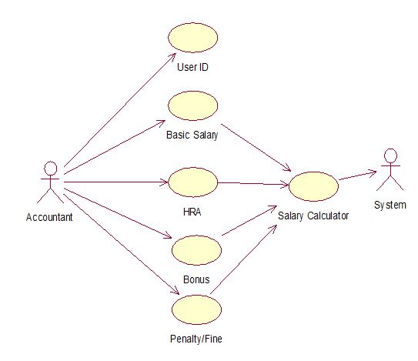](https://www.sanfoundry.com/wp-content/uploads/2013/07/software-engineering-multiple-choice-questions-answers-q2.png)  
a) Use Case  
b) Collaboration Diagram  
c) Class Diagram  
d) Object Diagram

3. Which UML diagram is shown below?  
[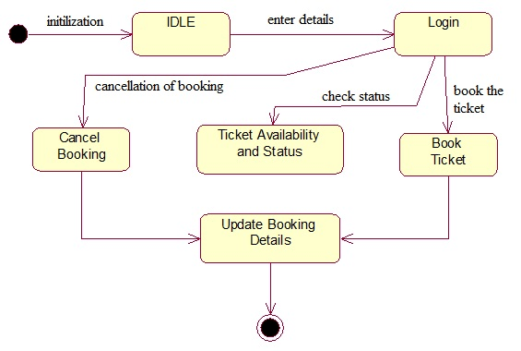](https://www.sanfoundry.com/wp-content/uploads/2013/07/software-engineering-multiple-choice-questions-answers-q3.png)  
a) Use Case  
b) State Chart  
c) Activity  
d) Object Diagram

4. Which UML diagram is shown below?  
[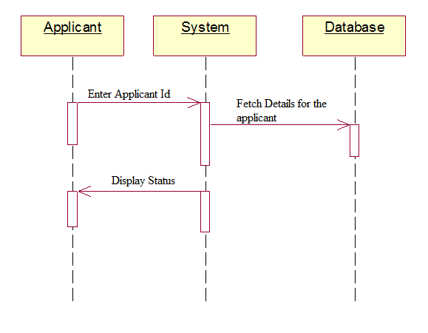](https://www.sanfoundry.com/wp-content/uploads/2013/07/software-engineering-multiple-choice-questions-answers-q4.png)  
a) Use Case  
b) Collaboration Diagram  
c) Sequence Diagram  
d) Object Diagram

6. Which UML diagram is shown below?  
[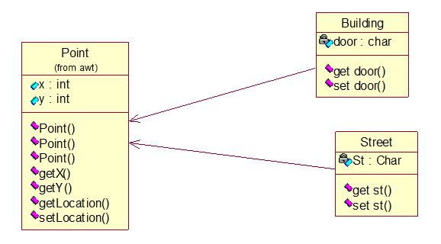](https://www.sanfoundry.com/wp-content/uploads/2013/07/software-engineering-multiple-choice-questions-answers-q6.png)  
a) Deployment diagram  
b) Collaboration Diagram  
c) Object Diagram  
d) Class Diagram

*(For Evaluator’s use only)*

|  |  |
| --- | --- |
| Comment of the Evaluator (if Any) |  |
| Evaluator’s Observation  Marks Secured: out of Full Name of the Evaluator:  Signature of the Evaluator Date of Evaluation: |
|  | |

#### DEPARTMENT OF COMPUTER SCIENCE AND ENGINEERING

#### SUBJECT CODE:19CS2211

**SOFTWARE ENGINEERING TUTORIAL WORKBOOK**

**Name of the Tutorial #4 How to draw use case,Class,Sequence ,Activity and State chart diagram, Online bank ATM by using star UML**

**Date of the Session: / / Time of the Session: to**

**Prerequisite:**

* + - **Software Engineering Methodologies..**
    - **Download the Star UML.**
    - **Basics of Software Engineering.**

## Pre-Lab Task:

**1. UML diagram that specifies sequences/ steps of operations to be performed**A. Activity diagram  
B. Use case diagram  
C. Class diagram  
D. E-R case diagram

**2. Which of the following statement is true?**a) Use case diagram is a dynamic model of interaction between actors and product in a use case  
b) Use case Description is a static model of use case supported by a product  
c) All of the mentioned  
d) None of the mentioned

**3. A UML diagram that facilitates requirements gathering and interacts between system and external users, is called as**A. Flowchart diagram  
B. Sequence diagram  
C. Use case diagram  
D. Data flow diagram

**4. Who consider diagrams as a type of Class diagram, component diagram, object diagram, and deployment diagram?**

A) structural  
B) behavioral  
C) non-behavioral  
D) non structural

**5.__________ represented by In UML diagrams, relationship between component parts and object.**

A) ordination

B) aggregation

C) segregation

D) increment

**In Lab Task:**

##### Online Bank ATM

An automated teller machine (**ATM**) or the automatic banking machine (**ABM**) is a banking subsystem ([subject](https://www.uml-diagrams.org/use-case-subject.html)) that provides bank customers with access to financial transactions in a public space without the need for a cashier, clerk, or bank teller.

Customer ([actor](https://www.uml-diagrams.org/use-case-actor.html)) uses bank ATM to Check Balances of his/her bank accounts, Deposit Funds, Withdraw Cash and/or Transfer Funds ([use cases](https://www.uml-diagrams.org/use-case.html)). ATM Technician provides Maintenance and Repairs. All these use cases also involve Bank actor whether it is related to customer transactions or to the ATM servicing.

sequence diagram for university admission process

**activity diagram for University admission process**

**state chart diagram for University admission process**

**Post Lab Task:**

**Draw all diagrams for the case study Railway Reservation System**

#### Writing space for the Problem:(For Student’s use only)

**1.Which type they considered Activity diagram, use case diagram, collaboration diagram, and sequence diagram as?**

A) non-behavioral

B) non-structural

C) structural

D) behavioral

**2.Which diagram is used to show interactions between messages are classified as?**

A) activity

B) state chart

C) collaboration

D) object lifeline

**3. Which diagrams are used to distribute files, libraries, and tables across topology of the hardware**

A) deployment  
B) use case  
C) sequence  
D) collaboration

**4. Which diagram that helps to show Dynamic aspects related to a system?**

A) sequence  
B) interaction  
C) deployment  
D) use case

**5. Simple name in UML Class and objects consist of __________.**

A) Letters  
B) Digits  
C) Punctuation Characters  
D) All of the mentioned

*(For Evaluator’s use only)*

|  |  |
| --- | --- |
| Comment of the Evaluator (if Any) |  |
| Evaluator’s Observation  Marks Secured: out of Full Name of the Evaluator:  Signature of the Evaluator Date of Evaluation: |
|  | |

#### DEPARTMENT OF COMPUTER SCIENCE AND ENGINEERING

#### SUBJECT CODE:19CS2211

**SOFTWARE ENGINEERING TUTORIAL WORKBOOK**

**Name of the Tutorial #5- 12**

**Guide and Monitor the Projects which students have been developed by Agile Development model scrum and uploading in GitHub**

**Date of the Session: / / Time of the Session: to**

**Prerequisite:**

* + - **Software Engineering Methodologies..**
    - **Download the Star UML.**
    - **Basics of Software Engineering.**

## Pre-Lab Task:

.

**In Lab Task:**

**Post Lab Task:**

#### Writing space for the Problem:(For Student’s use only)

*(For Evaluator’s use only)*

|  |  |
| --- | --- |
| Comment of the Evaluator (if Any) |  |
| Evaluator’s Observation  Marks Secured: out of Full Name of the Evaluator:  Signature of the Evaluator Date of Evaluation: |
|  | |